**System Design Document**

**For**

**ERAU Eagle Wallet**

Team Members:

* Samantha Balistreri
* Tyler Wise
* Joseph Moran
* Michael Fornito
* William Edwards
* Daniela Regueira

Table of Contents

**1. Overview** **1**

**2. Introduction** **2**

2.1 Purpose and Scope 2

2.2 Project Executive Summary 2

2.2.1 System Overview 2

2.2.2 Design Constraints 2

2.2.3 Future Contingencies 2

2.3 Glossary 3

**3. System Architecture** **3**

3.1 System Software Architecture 3

3.2 Internal Communications Architecture 4

**4. Human-Machine Interface** **4**

4.1 Inputs 4

4.1.1 Input Parameters 4

4.2 Outputs 5

4.2.1 User Input Feedback 5

4.2.2 Warning Messages 5

4.2.3 Data Collection 5

**5. Detailed Design** **6**

5.1 Overall System Design 6

5.1.1 System Data Flow Diagram 6

5.2 API Design 7

5.2.1 API UML Class Diagram 7

**6. Additional Figures** **7**

6.1 GUI For Human-Machine Interface 7

# 1. Overview

This document gives the detailed design of the Eagle Wallet project. There are descriptions of the system requirements, operating environment, human-machine interfaces, and processing logic.

# 2. Introduction

## 2.1 Purpose and Scope

The purpose of this document is to show the architecture and design of the ERAU Eagle Wallet application which is constructed with Android Studio. The scope of this project is to develop an application that allows Embry-Riddle Aeronautical University faculty, staff, and students to access their Eagle Card and dining account through their phone. The application allows the user to make purchases through their phone using the near-field communication (NFC) reader.

## 2.2 Project Executive Summary

The ERAU Eagle Wallet application will be a useful application for Embry-Riddle faculty, staff, and students to manage their payment accounts and purchase food with touchless technology. This application will allow users to add funds to their account, check their current balances, pay for food, access the student dorms and access their Eagle Card.

## 2.2.1 System Overview

The product to be produced will be an application that will allow Embry-Riddle faculty, staff, and students to access their Eagle Card and dining account on their phone. This application will be required to interface with hardware in order to take advantage of the near-field communication.

## 2.2.2 Design Constraints

The system was designed to be used for Android 8.0 and above. Any user with an operating system below this will not be able to use the functionality of this app. This constraint is due to the implementation of biometrics and NFC capabilities available in the app.

## 2.2.3 Future Contingencies

One contingency that might arise that will affect the current design of the system is integrating the ERAU Eagle Wallet application with the official Embry-Riddle application. The second contingency is development for IOS devices using the apple developer licenses.

## 2.3 Glossary

* IDE - Integrated Development Environment
* Android Studio - IDE where the application will be constructed
* NFC - Near-Field Communication
  + A set of communication protocols for communication between two electronic devices over a distance of 4 cm (1​1⁄2 in)
* Android Versions
  + Android 8 - Oreo, minimum required android version for the application
  + Android 9 - Pie
* Emulator - hardware or software that permits programs written for one computer to be run on another computer.
* API - a software intermediary that allows two applications to talk to each other
* Widget - a component of an interface, that enables that enables a user to perform a function

# 3. System Architecture

## 3.1 System Software Architecture

Figure 1. System software architecture. 1) User is any person that creates an account. 2) The Mobile Client is what the user uses to create an account as well as check their balance and make a payment. 3) The Backend Server is where user information is stored. 4) The Email System is used to confirm user account creation.

The following software was used in development of this project:

* Android Studio
* Microsoft SQL Server Management Studio

The mobile client was built using Android Studio with Java support. Android studio has tools to design, create and add elements to the app. Java was used to add functionality to the elements implemented in the app and connected the backend database to the front end of the app.

The backend API and Database were built with C# and SQL, respectively. These two backend elements are stored on a dedicated server.

## 3.2 Internal Communications Architecture

The App will communicate with the backend API via the HTTPS protocol. The backend API will communicate with the database via TCP hosted locally within the same server. The backend API will communicate with the email server via StartTLS to ensure encrypted and secure connections. The API will also communicate with the email server via the SMTP protocol to deliver mail to external users and IMAPS to allow recei mail from external users.

# 4. Human-Machine Interface

This section provides the detailed design of the system and subsystem inputs and outputs relative to the user/operator.

## 4.1 Inputs

The figures in section 6 illustrates the graphical design of the application. This section describes input parameters for the Eagle Wallet Application based on the graphical design.

### 4.1.1 Input Parameters

1. **Username -** The user shall enter their username where prompted on the login page (This will be more than likely their school email address).
2. **Password -** The user shall enter their password where prompted on the login page
3. **Add Payment Information -** The user shall input their payment information onto their account for the ability to add funds. Payment information includes: card credentials, address, email, and name
4. **Account to Use** - The user shall click which account on the app they want to use for a purchase, this includes meal plans, dining dollars or eagle dollars.
5. **Remove Payment Information** - The user shall input the payment option that they choose to remove from their account
6. **Add Funds** - The user shall add the amount of funds they want to their account (meal plans, sodexo, dinning, and eagle dollars)
7. **Create Account** - The user shall create an account with the following parameters (username, password, email. studentID, full name)

## 4.2 Outputs

The figures in section 7 illustrates the graphical design of the application. This section describes output responses to ensure the user that all inputs are valid, notify the user with feedback, and to improve the software’s fault tolerance.

### 4.2.1 User Input Feedback

1. **Payment Added -** The app shall notify the user when a payment has been successfully added to their account
2. **Payment Deleted -** The app shall notify the user when a payment has been successfully deleted from the their account
3. **Purchase Completed -** The app shall notify the user when a purchase has gone through and been completed

### 4.2.2 Warning Messages

1. **Incorrect Username/Password -** This warning is displayed to the user if the user does not put the correct username or password into the login page.
2. **Payment method is not valid -** This warning is displayed to the user if the payment method they put into the app in order to add funds to their account is not a valid form of payment
3. **Insufficient Funds -** This warning is displayed to the user if the user makes a purchase and they do not have the necessary funds in their account
4. **Payment Failed -** This warning is displayed to user if the payment has failed due to something other than insufficient funds
5. **Required Fields -** The app shall notify the user when a particular field is left blank when trying to submit information.

### 4.2.3 Data Collection

1. **Eagle Wallet Database -** The database contains all the following information:

* Student name
* Email address
* Password
* ID Number
* Payment information
  + Meal Plans
  + Dining Dollars
  + Eagle Bucks

1. **Android System Information**

* User Biometrics

# 5. Detailed Design

## 5.1 Overall System Design

## 5.1.1 System Data Flow Diagram

## 5.2 API Design

## 5.2.1 API UML Class Diagram

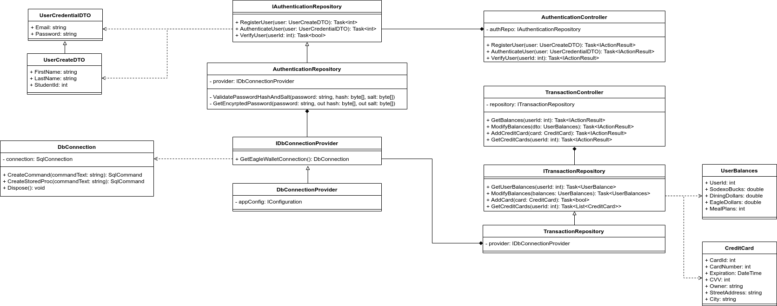

# 6. Additional Figures

## 6.1 GUI For Human-Machine Interface



